HLA-A-B-DR SSP Combi Tray Lot No: 0R8 Expiry Date: 2026-06-01

(101.701-24/06 – 24u/06u)

Name:___________________

Sample ID:_______________

DNA Conc.(ng/ul):__________

Test Date:_______________

Tested By:

Review Date:_________________

Reviewed By:_________________

Interpretation:___________ Failed lanes: ___________ Comments:_________________

Gel Picture

PHOTO DOCUMENT

HLA-A low resolution

HLA-B low resolution

DR low resolution

Abbreviations
ICB: Internal Control Band
AmpS: Amplicon Size

Notes:
Product sizes are approximate. For detailed information, see the lot-specific Specificity Table and Interpretation Table.
This table is intended as a guide. For interpretation always use the Interpretation Table and/or Specificity Table.

HLA-A low resolution primer set

HLA-specific PCR products shorter than 125 base pairs have a lower intensity and are less sharp than longer PCR products.
Primer mix 3 may faintly amplify the A*30:04:01:01-30:04:03, 30:06, 30:09:01:01-30:09:01:02, 30:17, 30:29, 30:46, 30:77, 30:89-30:90, 30:99, 30:103, 30:105, 30:117, 30:139, 30:150, 30:155, 30:160 and 30:183 alleles.
Primer mixes 9 and 10 may weakly amplify the A*34 alleles.
Primer mix 22 might faintly amplify most A*11 alleles.
Primer mixes 10, 13, 14, 20 and 23 may have a tendency of giving rise to primer oligomer formation.
Primer mixes 2, 15, 23 and 24 may give rise to a lower yield of HLA-specific PCR product than the other HLA-A low primer mixes.
Primer mixes 3, 15, 17, 20 and 24 may have tendencies of unspecific amplifications.
Primer mixes 20 and 21 may generate a false positive band of about 560 base pairs. This band should be disregarded when interpreting HLA-A low resolution typings.

HLA-B low resolution primer set

HLA-specific PCR products shorter than 125 base pairs have a lower intensity and are less sharp than longer PCR products.
Primer mix 28 may give rise to a lower yield of HLA-specific PCR product than the other HLA-B low resolution primer mixes in B*40, B*41, B*45, B*49 and B*50 alleles.
Primer mixes 28, 29, 33, 42, 53 and 63 may give rise to a lower yield of HLA-specific PCR product than the other HLA-B low resolution primer mixes.
Primer mixes 32, 33, 38, 42, 59, 62, 65, 66 and 70 have tendencies of unspecific amplifications, most pronounced in primer mix 33.
Primer mixes 25, 27, 43, 44, 50, 55 and 69 have a tendency giving rise to primer oligomer formation.
The B*57 and B*58 alleles might be faintly amplified by primer mix 33.
Many C*17 alleles may be faintly amplified by primer mix 49.
Primer mix 67 may generate a false positive band of about 800 base pairs. This band should be disregarded when interpreting HLA-B low resolution typings.
Primer mix 63 may give rise to a lower yield of B*54 alleles than the other B low primer mixes.
Primer mix 63 may amplify B*44:05 samples.
The Bw4-associated HLA-A specificities A9, A23, A24, A2403, A25 and A32 are not amplified by the primer pair in primer mix 70.
DR low resolution primer set

HLA-specific PCR products shorter than 125 base pairs have a lower intensity and are less sharp than longer PCR products.
Primer mixes 73, 80, 87, 88 and 91 to 94 may have a tendency giving rise to primer oligomer formation.
Primer mix 91 has a tendency of primer oligomer formation and also has an intense primer cloud due to the high number of primers present in the primer mix.
Primer mixes 75, 80, 81, 84 and 92 may have tendencies of unspecific amplifications, most pronounced in primer mix 75.
In primer mix 75 the positive control band may be weaker than for other A-B-DR primer mixes.
Primer mix 96 contains a negative control, which will amplify the majority of HLA amplicons as well as the amplicons generated by the control primer pairs matching the human growth hormone gene. HLA-specific PCR product sizes range from 75 to 200 base pairs and the PCR product generated by the HGH positive control primer pair is 200 base pairs.

HLA-A low resolution Interpretation Table
¹HLA-A, HLA-B and HLA-DRB alleles listed on the IMGT/HLA web page 2022-January-13, release 3.47.0, www.ebi.ac.uk/imgt/hla.
²Alleles that have been deleted from or renamed in the official WHO HLA Nomenclature up to and including the last IMGT/HLA database release can be retrieved from web page http://hla.alleles.org/alleles/deleted.html.
³The serological reactivity of all HLA-A alleles is not known. The grouping of not serologically defined alleles is taken from Tissue Antigens 73, 95-170, 2009.
⁴The HLA-A alleles will be grouped into their corresponding serological specificities, except that the following alleles give rise to identical amplification patterns. These alleles can be separated by the respective high resolution SSP primer sets.

Alleles | Alleles
A*01:26, 01:136, 01:192, 01:380:01:01-01:380:01:02, A*11:94, 11:112, 11:211, 11:290, 11:326 | A*23:66, 23:99, A*24:14:01:01-24:15, 24:51-24:53, 24:57, 24:64, 24:94, 24:114, 24:138, 24:188, 24:222N, 24:228, 24:291, 24:296, 24:304, 24:316, 24:324, 24:412, 24:481, 24:515, C*04:01:03
A*01:28, 01:229, 01:299, A*11:282 | A*23:104, 23:113N, A*24:02:01:01-24:11N, 24:13:01-24:13:02, 24:17:01:01-24:17:01:02, 24:20:01:01-24:23, 24:25-24:43, 24:45N-24:50, 24:54-24:56:02, 24:58-24:63, 24:66-24:70, 24:72-24:81, 24:83N-24:91, 24:93, 24:95-24:103, 24:105-24:113, 24:115-24:137, 24:139-24:187, 24:189-24:203, 24:205-24:210, 24:212, 24:214-24:221, 24:223-24:227, 24:229-24:242, 24:244-24:290, 24:292-24:295, 24:297-24:303N, 24:305-24:314, 24:317-24:323N, 24:325-24:391, 24:393-24:411, 24:413-24:457, 24:459-24:470, 24:472-24:480, 24:482-24:514N, 24:516-24:526, 24:528-24:550, 24:552-24:554, 24:556N, 24:558-24:565
A*01:43, A*11:271 | A*25:78, A*26:01:63, 26:57, A*66:15
A*03:215, 03:225, 03:249, 03:322, 03:414, A*25:77 | A*26:92, A*66:42
A*11:11, A*34:19 | A*30:01:01:01-30:04:03, 30:06-30:07, 30:09:01:01-30:20, 30:22-30:54, 30:56-30:88, 30:90-30:124, 30:126-30:139, 30:141-30:149, 30:151-30:162, 30:164-30:176, 30:178N-30:185, 30:187-30:200, B*07:260, C*12:328
A*11:116, 11:140, 11:199:01-11:199:02, 11:222, A*66:23 | A*31:08, A*33:53
A*11:325, A*24:555 | A*31:109, A*33:125, 33:131
A*23:14:01-23:14:02, 23:105, A*24:24, 24:71, 24:315, 24:392, 24:527 | A*34:01:01:01-34:01:07, 34:05-34:06, 34:11-34:12, 34:14, 34:16-34:18, 34:23, 34:27, A*66:40

Abbreviations
w: might be weakly amplified.

HLA-B low resolution Interpretation Table

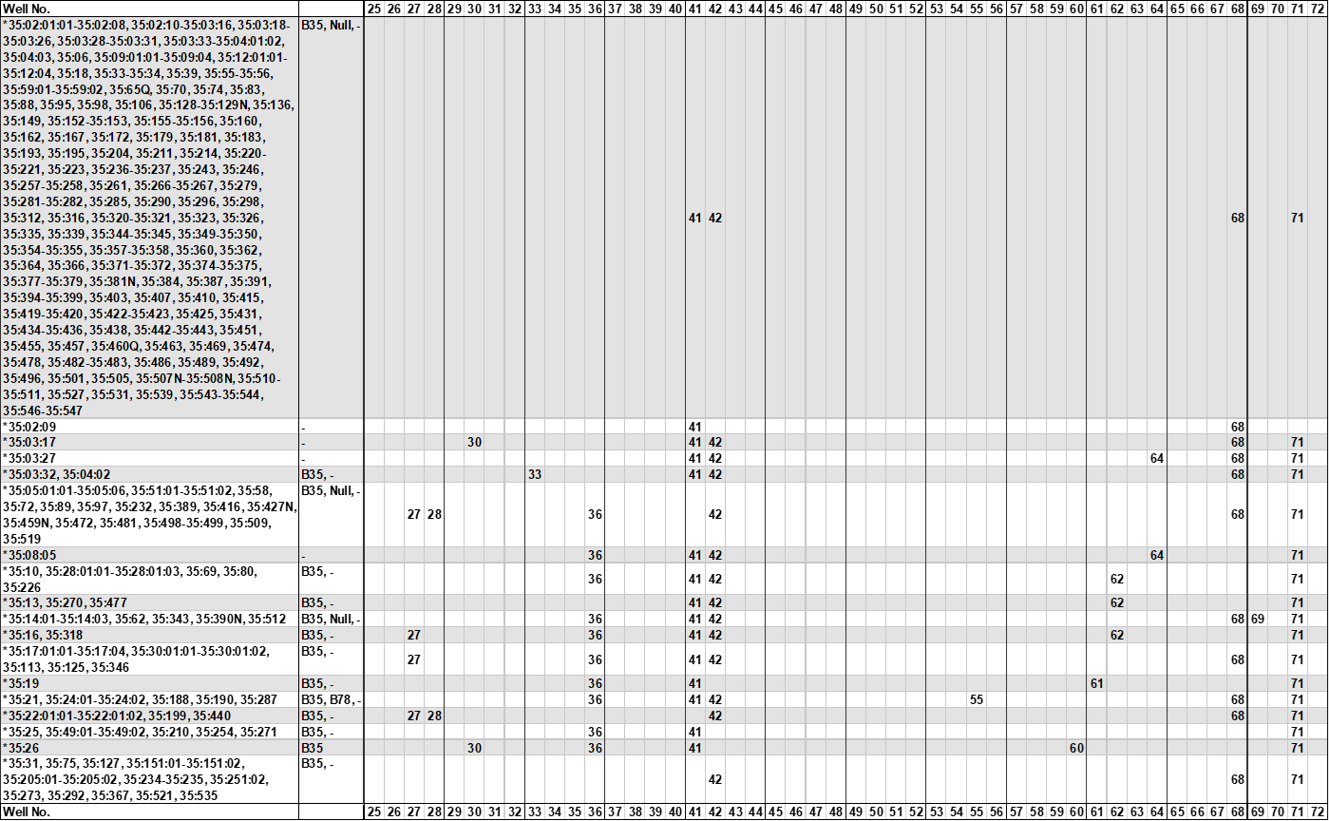

¹HLA-A, HLA-B and HLA-DRB alleles listed on the IMGT/HLA web page 2022-January-13, release 3.47.0, www.ebi.ac.uk/imgt/hla.
²Alleles that have been deleted from or renamed in the official WHO HLA Nomenclature up to and including the last IMGT/HLA database release can be retrieved from web page http://hla.alleles.org/alleles/deleted.html.
³The serological reactivity of all HLA-B alleles is not known. The grouping of not serologically defined alleles is taken from Tissue Antigens 73, 95-170, 2009.
⁴The HLA-B alleles will be grouped into their corresponding serological specificities, except that following alleles give rise to identical amplification patterns.
These alleles can be separated by the respective high resolution SSP primer sets.

Alleles | Alleles
B*07:349, B*42:05:01-42:05:02 | B*40:496, B*41:62
B*08:26:01-08:26:02, 08:50, 08:62, 08:85, 08:94, 08:242, 08:263, 08:265, 08:272, B*42:07, 42:24, 42:26 | B*53:30, B*58:111
B*13:35, 13:59, 13:71, 13:108, 13:140, B*44:135, 44:158, 44:184 | B*53:39, B*57:128, B*58:100
B*14:08:01-14:08:02, 14:55, B*39:01:35, 39:30, 39:32-39:33, 39:47, 39:50, 39:74, 39:82, 39:102, 39:107, 39:112, 39:128, 39:136, 39:171, 39:174 | B*55:04, 55:08, 55:49, 55:86, B*56:01:05, 56:01:13, 56:15, 56:19N, 56:22
B*18:29, 18:72:01-18:72:03, 18:92, 18:175, B*35:01:55, 35:01:62, 35:32:01-35:32:03, 35:37, 35:53N, 35:64:01-35:64:02, 35:68:01-35:68:02, 35:99, 35:118-35:119, 35:174, 35:369, 35:409, 35:433, 35:523 | B*57:67:01, B*58:36

Abbreviations
w: might be weakly amplified.
?: nucleotide sequence information not available for the primer matching sequence.

DR low resolution Interpretation Table

¹HLA-A, HLA-B and HLA-DRB alleles listed on the IMGT/HLA web page 2022-January-13, release 3.47.0, www.ebi.ac.uk/imgt/hla, www.ebi.ac.uk/imgt/hla.
²Alleles that have been deleted from or renamed in the official WHO HLA Nomenclature up to and including the last IMGT/HLA database release can be retrieved from web page http://hla.alleles.org/alleles/deleted.html.
³The serological reactivity of all DRB alleles is not known. The grouping of not serologically defined alleles is taken from Tissue Antigens 73, 95-170, 2009.
⁴The HLA-DRB1, -DRB3, -DRB4 and -DRB5 alleles will be grouped into their corresponding serological specificities, except that following alleles give rise to identical amplification patterns:

Alleles | Alleles
DRB1*03:126, DRB1*13:193 | DRB1*11:293, DRB1*13:45
DRB1*08:09:02, DRB1*14:15 | DRB1*12:57, DRB3*02:111
DRB1*08:20, DRB1*13:18, 13:47, 13:55, 13:158:01-13:158:02, 13:164, 13:232, 13:286 | DRB1*13:13, 13:119, 13:154, 13:156, DRB1*14:84, 14:116, 14:144
DRB1*08:31, DRB1*11:05, 11:209 | DRB1*13:44, 13:86, 13:206, DRB1*14:183
DRB1*08:41, 08:75, DRB1*11:67, 11:193:01-11:193:02 | DRB1*13:235, DRB1*14:98
DRB1*11:264, DRB1*13:05:01:01-13:05:03, 13:07:01-13:07:02, 13:11:01-13:11:02, 13:14:01-13:14:03, 13:21:01:01-13:21:02, 13:42:01-13:42:02, 13:46, 13:49:01-13:50:03, 13:62, 13:100, 13:108, 13:132, 13:136, 13:150, 13:169, 13:189, 13:199, 13:203, 13:229, 13:246, 13:284, 13:302 | DRB1*13:314, DRB1*14:37

Abbreviations
w: might be weakly amplified.
?: nucleotide sequence information not available for the primer matching sequence.

